Problem Queries:
/* ===============================================================
- Q1. Can you get all data about movies?
=============================================================== */
a1.use project_movie_database;
a2. select count (*) as movie_table_count from movies;

a3. select * from movies;
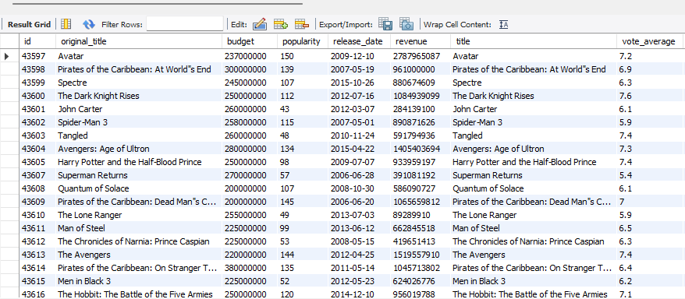

/* ===============================================================
b) Q2. How do you get all data about directors?
=============================================================== */
b1. select count (*) as directors_table_count from directors;

b2. select * from directors;
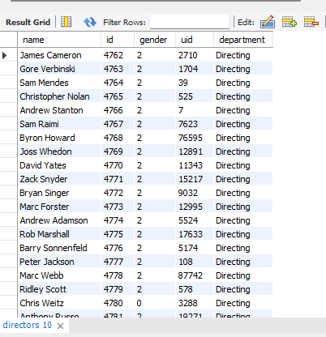
/* ===============================================================
c) Q3. Check how many movies are present in IMDB?
=============================================================== */
c1. select count (*) as movie_table_count from movies;
/* =====================================================================
d) Q4. Find these 3 directors: James Cameron ; Luc Besson ; John Woo?
=================================================================== ===*/

d1. select * from directors where name IN ('James Cameron','Luc Besson','John Woo');

/* =====================================================================
e) Q5. Find all directors with name starting with S.
=================================================================== ===*/

e1. select * from directors where name like 'S%';


/* =====================================================================
f) Q6. Count female directors? -- gender: 0/2 = Male, 1 = Female
=================================================================== ===*/

f1. select count (*) AS female_director_count from directors where gender='1';



/* =====================================================================
g) Q7. Find the name of the 10th first women director?
=================================================================== ===*/

g1. select name from directors where gender='1' order by id asc limit 9,1;


/* =====================================================================
h) Q8. What are the 3 most popular movies?
=================================================================== ===*/
h1. select * from movies order by popularity desc limit 3;



/* =====================================================================
i) Q9. What are the 3 most bankable movies?
-- "bankable" = highest profit (revenue - budget)
=================================================================== ===*/
i1. select title,budget,revenue,(revenue - budget) AS profit from movies order by profit desc limit 3;


/* =====================================================================
j) Q10. What is the most awarded average vote since January 1st, 2000?
=================================================================== ===*/
j1. select title, release_date, vote_average from movies where release_date >= '2000-01-01' order by vote_average desc limit 1;



/* =====================================================================
k) Q11. Which movie(s) were directed by Brenda Chapman?
=================================================================== ===*/
k1. select m.original_title, m.title, m.director_id, d.name AS director_name from movies as m join directors d on m.director_id = d.id where d.name='Brenda Chapman';

k2. select * from directors where name = 'Brenda Chapman';
k3. select * from movies where director_id = 4801;
“No movies in this dataset are linked to Brenda Chapman (director ID 4801); the directors table includes her as a reference entry, but no corresponding movie record exists."
/* =====================================================================
l) Q12. Which director made the most movies?
=================================================================== ===*/
l1. select d.name as director_name, count(m.id) as movies_count from movies as m join directors d on m.director_id = d.id group by director_name order by movies_count desc;
"Three directors are tied for the most movies in the dataset, each with 3 films: Gore Verbinski, Sam Raimi, and Peter Jackson."


/* =====================================================================
m) Q13. Which director is the most bankable?
-- "bankable" = highest total profit across all their movies
=================================================================== ===*/
m1. select d.name as director_name, sum(m.revenue - m.budget) as total_profit, count(m.id) as movies_count from movies as m join directors d on m.director_id = d.id group by director_name order by total_profit desc limit 1;



